**Final Project Mechanical Design Proposal**

The final project requires the robot to navigate to a race track and complete as many laps as possible in a 5 minutes interval. In order to complete this task, the mechanical design of the robot must be considered in many aspects. Firstly we have to consider the size of the robot, we want the robot to be as compact as possible, so it takes less space to turn. Secondly, since we want our robot to run as fast as possible, we need to consider the stability and the center of the gravity of the robot. Besides that, the accuracy of measurement is also important, we want our robot to be as accurate as possible in the process of localization and navigation, so that it doesn’t have to spend extra time on adjusting itself and correcting errors.

With the above considerations, three alternative mechanical designs were made. They are shown in the Figures below with pros and cons of each design.

**Design A:**

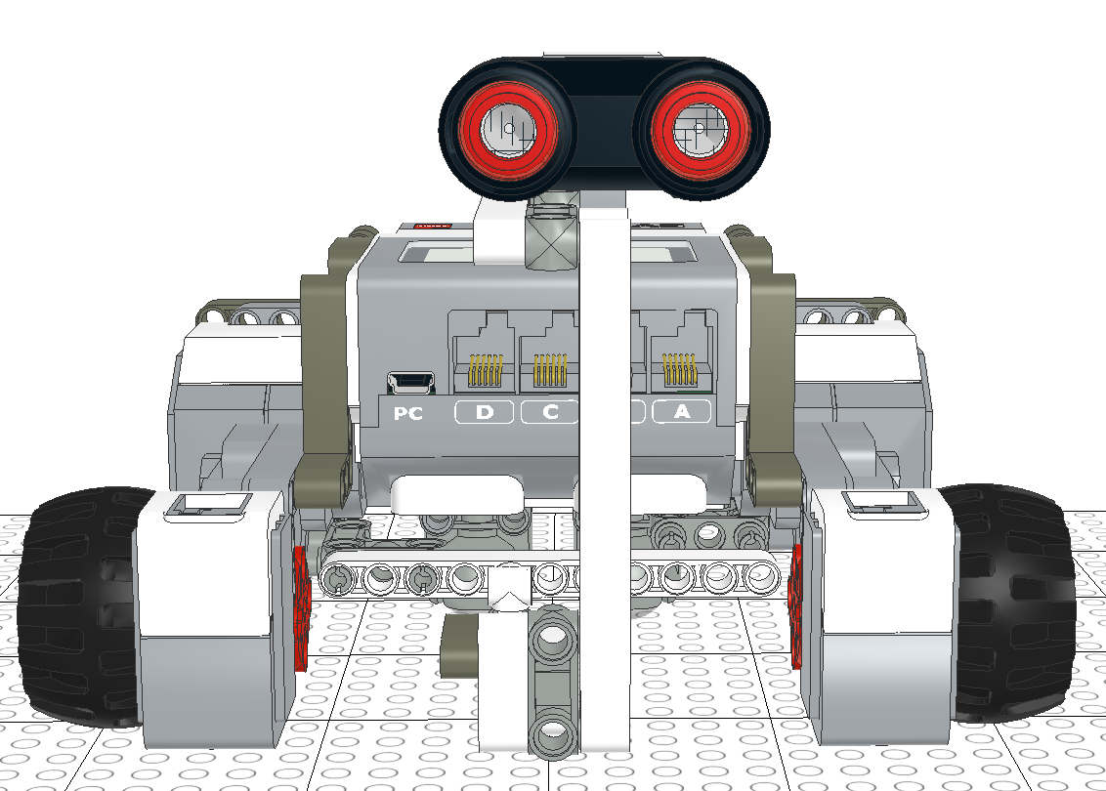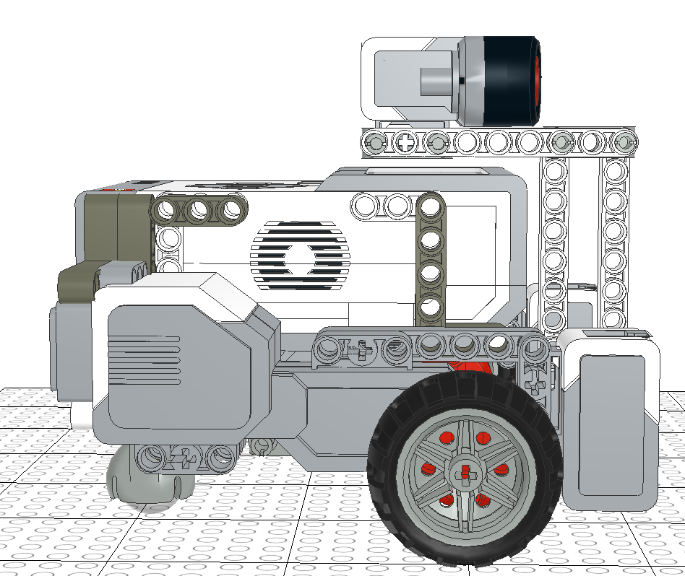**Figure 1: Front View of Design A Figure 2: Side View of Design A**

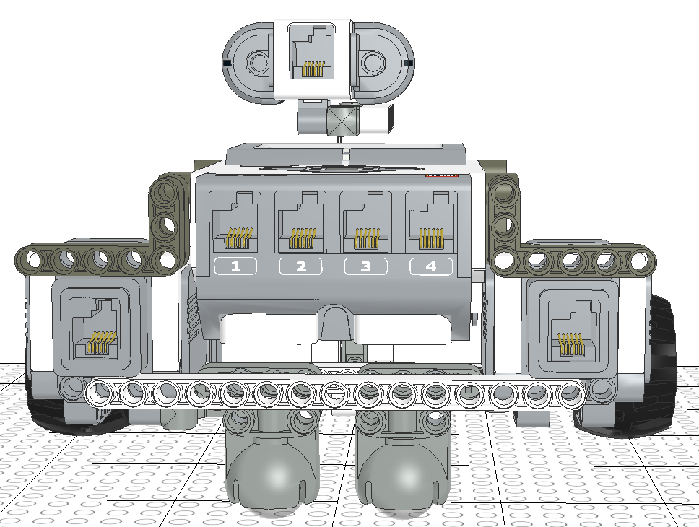

**Figure 2: Back View of Design A**

Advantage of Design A:

* Two color sensors are in a horizontal line and relatively far from each other. Besides that, the color sensors are not too close to the ground, since in the previous labs we found that when the color sensor is too close to the ground, it may fail to detect color.
* An extra ball caster was added at the back of the robot. After testing we found that adding an extra ball caster will increase the stability of the robot and decrease error.
* The design is relatively compact, all the hardware components are close to the EV3 brick, which means the robot will take smaller space to turn.
* The design is symmetrical, therefore the center of gravity is in the middle of the robot, which makes it relatively more stable.

Disadvantages of Design A:

* The Ultrasonic sensor is in a fixed position and angle, therefore if the obstacles are on the side of the Ultrasonic sensor, there is a chance that the sensor fails to detect it.
* The center of rotation (the midpoint between two wheels) is not the same point as the center of the EV3 brick. Since the position of the robot is defined as the position of the center of EV3 brick, in this case the robot is unable to maintain its position while turning.

**Design B:**

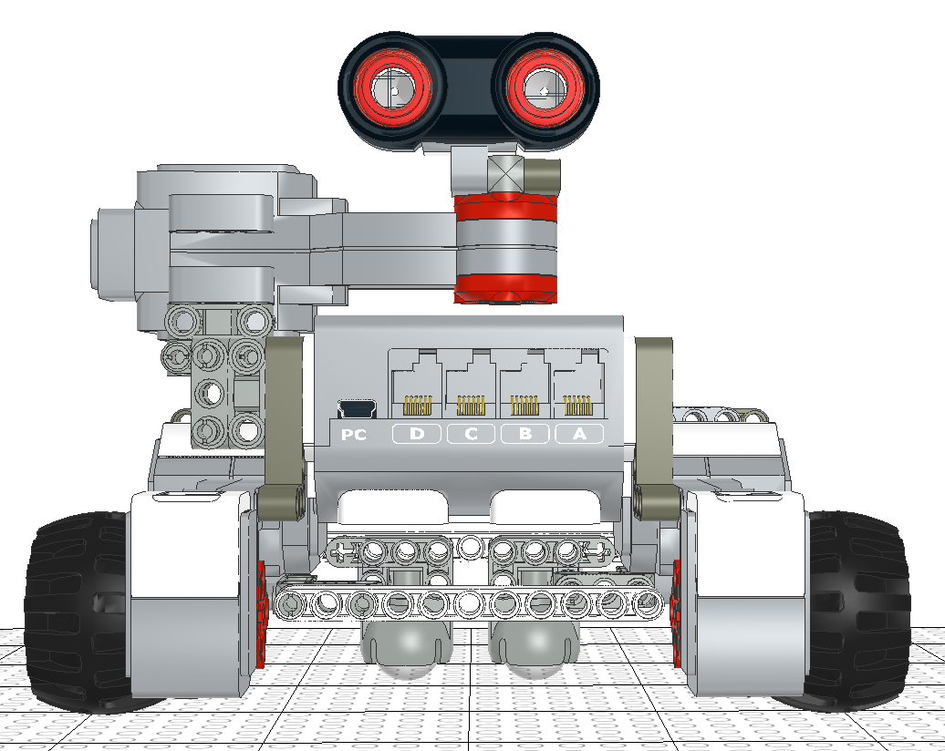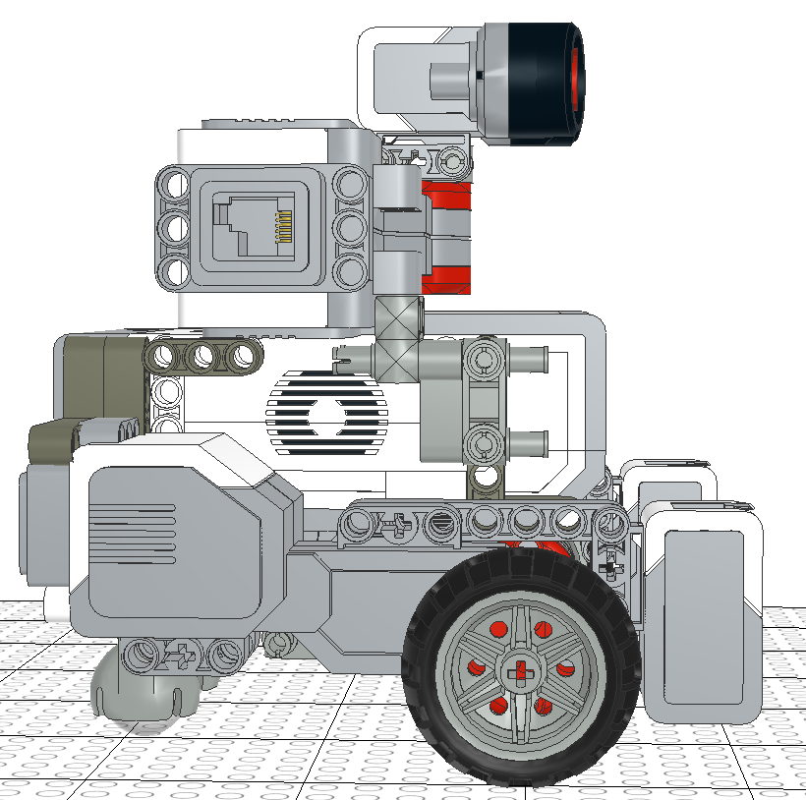

**Figure 4: Front View of Design B Figure 5: Side View of Design B**

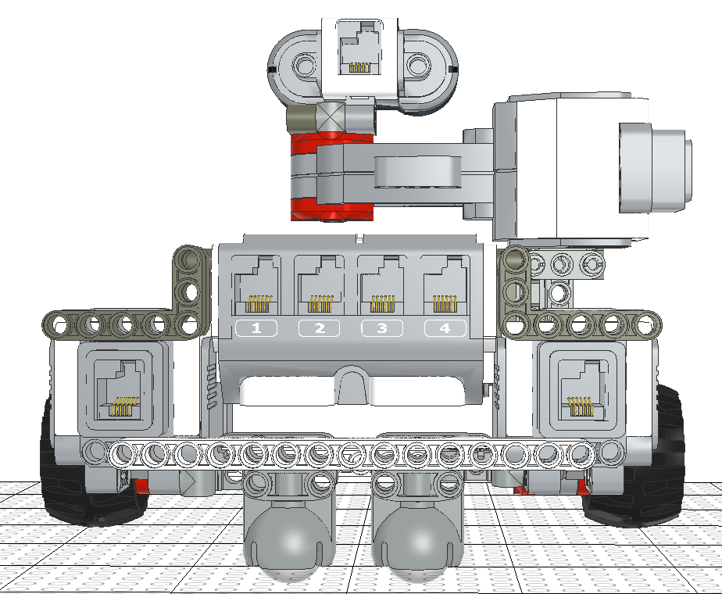

**Figure 6: Back View of Design B**

Advantages of Design B:

* The positions of the two color sensors are maintained from Design A, therefore the sensor can detect the color accurately.
* An extra ball caster was also added at the back of the robot. Adding an extra ball caster will increase the stability of the robot and decrease error.
* The ultrasonic sensor in this design is controlled by a motor, which means now the ultrasonic sensor can turn by itself. This reduces the unnecessary turning of the robot in the process of localization.
* The height of the robot in this design is relatively high, however, the length and width of the robot is the same as Design A, so this robot is also relatively compact. Therefore, it doesn’t need much space to turn.

Disadvantages of Design B:

* This design increases the complexity of software design. Since an extra motor is added in this design, extra codes must be added to the software design in order to control the motor.
* The motor is not very effective in the process of avoiding obstacles. In the localization process, we can simply turn the motor so that the ultrasonic sensor can detect the distance in all directions. However, when the robot is moving forward, or in the process of avoiding obstacles, we don’t know which direction the obstacle is in, so we can’t continuously turn the sensor, we can only keep the sensor facing to the front. In this case, the motor is unused when avoiding obstacles.
* Hardware components are concentrated at the left sides of the robot. So the left side of the robot is heavier than the right side, which means the center of gravity is no longer in the middle of the robot.

**Design C:**

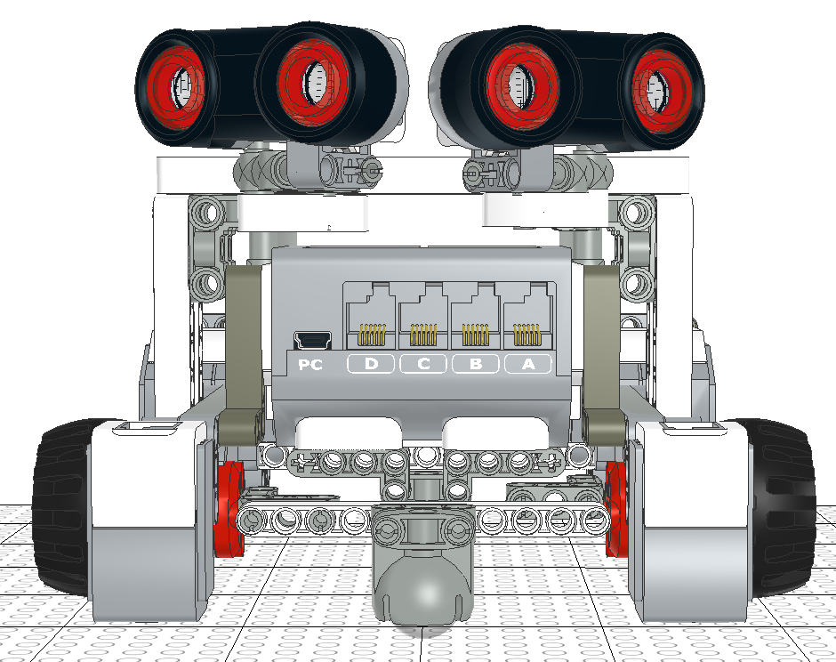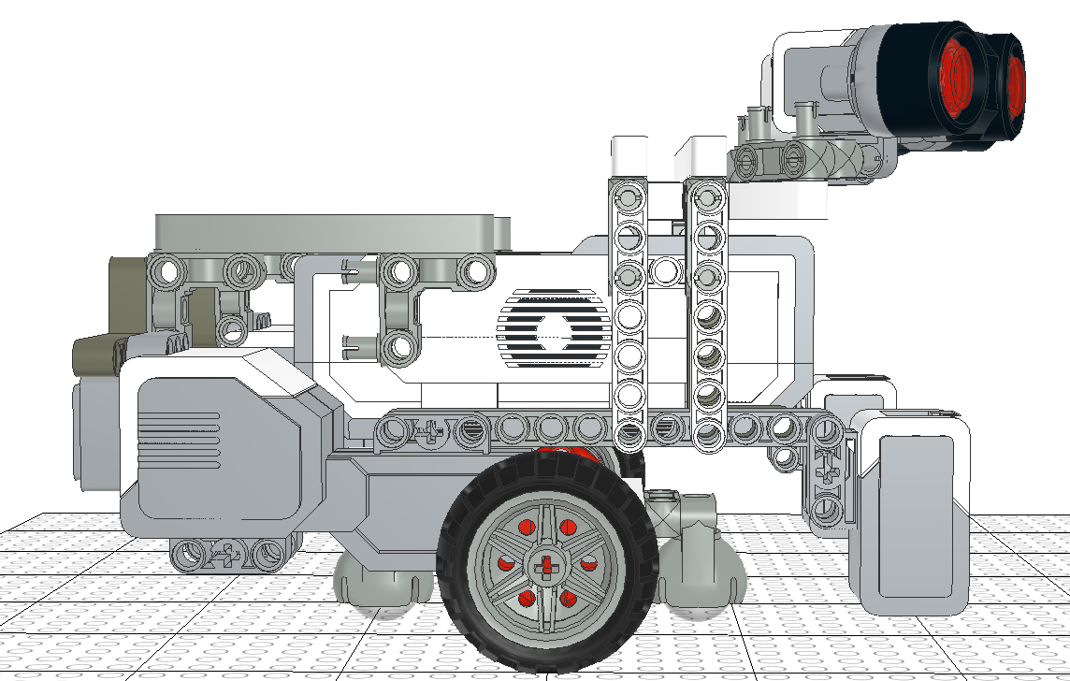

**Figure 7: Front View of Design C Figure 8: Side View of Design C**

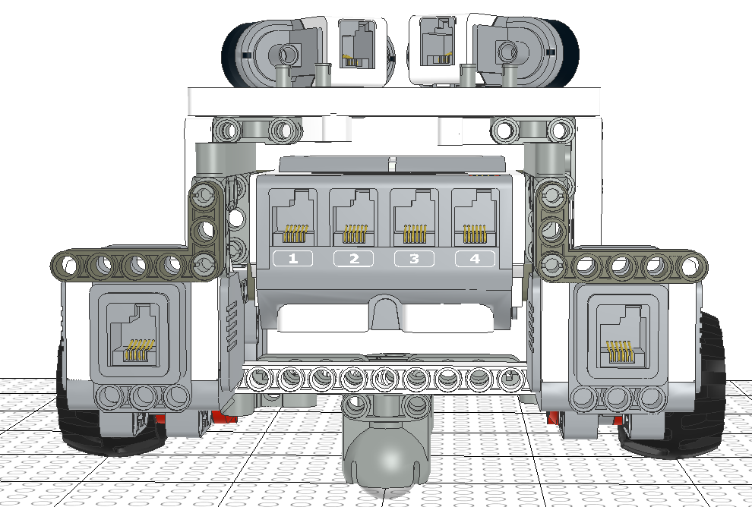

**Figure 9: Back View of Design C**

Advantages of Design C:

* In this design, two Ultrasonic sensors are implemented at 30 degrees and -30 degrees. This solves the problem in design A, where using one ultrasonic sensor may fail to detect the objects on the side of it. In this design, the two ultrasonic sensors can detect objects both in front of the robot and on the sides of the robot.
* The two motors and two wheels are moved backward in this design, so that the center of rotation (midpoint between two wheels) is at the same point as the center of the robot. In this case, the position of the robot remains constant while turning, which makes the software implementation easier.
* An extra ball caster is added at the front of the robot in order to keep the robot balance.
* The robot is symmetrical, therefore the center of gravity is in the middle of the robot.

Disadvantages of Design C:

* This design is relatively not compact since the length of the robot is too long. Therefore greater space is needed for the robot to make turns.
* Adding an extra Ultrasonic sensor will increase the complexity of software design. When an obstacle is in the front of the robot, both sensors can detect the obstacle, however, the two sensors are very likely to have different readings, at this time it is hard to decide which data to use in order to avoid the obstacle.